East Los Angeles-Montebello
Business and Professional Women
Program featuring Monterey Park Police
Sergeant Vanessa Delgado
Wednesday, November 27, 2024

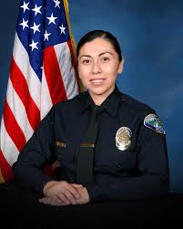

Networking is at 5:00 P.M. with dinner at 5:30 P.M. to be ordered from the menu at Marie Callendar’s Restaurant, 220 S. Atlantic Blvd., Monterey Park. Reservations are required. Call (626) 307-5650 or E-mail lindalwilson@juno.com for reservations or further information.

