East Los Angeles-Montebello BPW
With the presentation of the “Young Careerist 2025” award to Dr. Shawndeeia Drinkard
Wednesday, January 22nd

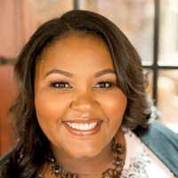
Dr. Shawndeeia Drinkard

Networking at 5:00 P.M. with dinner at 5:30 P.M. to be ordered from the menu at Marie Callendar’s Restaurant, 220 S. Atlantic Blvd., Monterey Park. Reservations are required . Call (626) 307-5650 or E-mail lindalwilson@juno.com for reservations or further information.

Dr. Shawndeeia Drinkard is The Boys and Girls Club of West San Gabriel Valley and the Eastside Director of Community Health and Wellness. Previously, she volunteered for the Boys and Girls Club. She also volunteered as a Program and Outreach Assistant for Foster Care Resource Group and is the Executive Director of Urban Mental Health and Wellness Initiative. She has a Bachelor’s Degree in Psychology from Mount Saint Mary’s University and a PhD. in Clinical Psychology from Alliant International University, Los Angeles.

