Sierra Mar District BPW Winter Conference
Featuring Jannel Rap, GINA for Missing Persons, and Larissa Matzek, Executive Director of Crossroads for Women with CFBPW State Rep. Denise Luckhurst on Saturday, January 18th

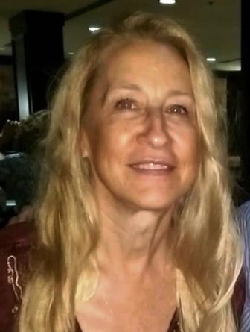 | 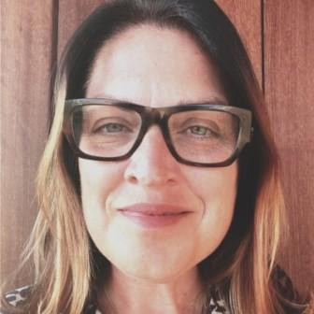 | 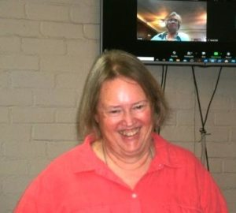
Jannel Rap Larissa Matzek Denise Luckhurst

The program starts at 9:00 A.M. at St. Paul’s Lutheran Church, 2009 S. Garfield Avenue, Monterey Park. The meeting is open to all interested members of the public.

Date: Saturday, January 18th_ Time: _9:00 A.M._______

For more information and to make a reservation contact: Linda Wilson at (626) 307-5650 or lindalwilson@juno.com

