Women’s History Month Event
The Public is Invited.

Sponsored by the East Los Angeles-Montebello Business and Professional Women at Marie Callender’s Restaurant, 220 S. Atlantic Blvd., Monterey Park. Reservations are required. Call (626) 307-5650 or E-mail Linda at lindalwilson@juno.com for reservations or further information

Street Address
City

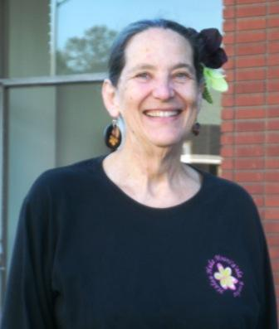

Mitchell is on the Bill Screening Committee for the California Federation of Business and Professional Women and Vice President of East Los Angeles-Montebello BPW. She is a retired educator. She worked at John Marshall High School in Los Angeles as an English teacher, basketball and baseball coach, and sponsored ACE (Architecture, Construction, and Engineering Club). For reservations lindalwilson@juno.com.
Tuesday, March 26, 2025
^{5:00 P.M. Networking and}
^{5:30 P.M. Meeting and Program}

Jo Anne Mitchell will make a presentation for Women’s History Month

