Sierra Mar BPW District
Annual Conference
Featuring Jill Welker “Volunteering in the Ukraine”; Dr. Shawndeeia Drinkard, Sierra Mar’s Young Professional; Frances Hale, Lutheran Social Services, speaking on “Disaster Responses” with CFBPW State President Anne Marie Johnson – Saturday, April 19th

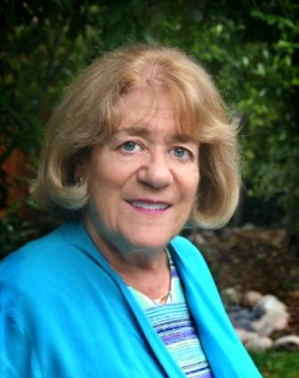  CFBPW President Anne Marie Johnson | 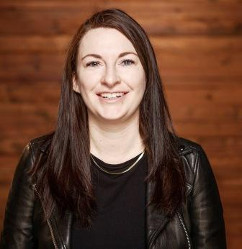  Morning Speaker Jill Welker on “Volunteering in the Ukraine” | 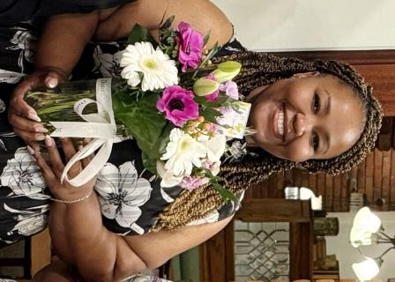  Sierra Mar Young Professional Dr. Shawndeeia Drinkard luncheon speaker | 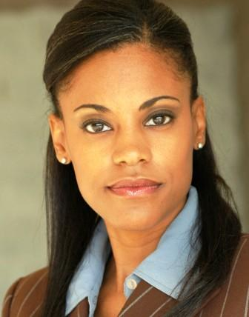  Afternoon speaker Frances Hale, Lutheran Social Service, speaking on “Disaster Responses”

The meeting starts with registration at 8:45 A.M., Memorial Service starting at 9:00 A.M. with the program starting at 9:15 A.M. at St. Paul’s Lutheran Church, 2009 S. Garfield Avenue, Monterey Park. The meeting is open to all interested members of the public.

Date: Saturday, April 19th_ Time: _8:45/9:00 A.M._______

For more information and to make a reservation contact:
Linda Wilson at (626) 307-5650 or lindalwilson@juno.com

